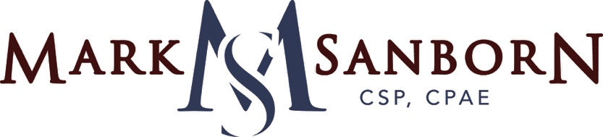
Dr
Dr

CLIENT PRE-PROGRAM QUESTIONNAIRE

Name of CLIENT or GROUP: Date:

This questionnaire enables Mark to tailor his presentation to meet your needs. Please answer all questions that are relevant to your event and return at your earliest convenience. Answers can be typed directly into this form (boxes expand as you type) to save and return by e-mail.

Primary on-site contact:
Title:
Company:
Address:
Phone: Cell Phone:
Email:
Website:

Secondary on-site contact:
Title:
Company:
Address:
Phone: Cell Phone:
Email:

The Event
Dr
Dr
Type of Event (Annual Meeting, Awards Ceremony, etc.):
Major objective of this event:
Program theme:
Meaning of theme to your group:

How did you learn about Mark?
Why did you choose Mark as the speaker for your event?
Which of his topics are you most interested in?
What would you like his presentation to accomplish?

Dates of your entire event:
Begins: Ends:
Exact schedule for Mark’s participation:
Time Function Location
What takes place immediately before and after Mark’s presentation (another speaker, meal function, break, etc.)?
Before:
After:

Best time for Mark to do his A/V and room check (Mark needs 15-20 minutes when the meeting room is empty):
What slide size will your projectors be using? 4:3 (standard) or 16:9 (widescreen)?
(Note: Mark will default to 16:9 if not checked)

Proper attire for this event (black-tie, business, etc.):
Other professional speakers on this program:
Speaker: Topic: Day:
Speaker: Topic: Day:
Speaker: Topic: Day:
Professional speakers have you used in the past:
Speaker: Year:
Speaker: Year:
Speaker: Year:

What did you specially like/dislike about their presentations? Why?
Like: Dislike:

Would you like information about purchasing Mark’s books as gifts for your attendees?
Yes No

Logistical Information
Dr
Dr
Name of car service providing local ground service?
Phone number:
Confirmation number for airport pickup reservation?
What time should Mark be ready in front of the hotel/venue for return to the airport?
Confirmation number for return reservation:

Hotel Name:
Address:
Phone:
Meeting Room:
Confirmation number for Mark’s hotel room reservation:
(Please ensure this room reservation is prepaid/charged to the master account)

Meeting location if different from hotel:
Address:
Phone:
Meeting Room:
Will you be using Image Magnification (IMAG)? Yes No
Will there be a video crew onsite? Yes No
If so, what is the company name:

Audio and videotaping of Mark’s presentation is not allowed without a separate written release. Would you like more information about taping rights? Yes No

Audience
Dr
Dr
Number Attending:
Spouses included: Yes No
Percentage of males/females: Average age of group:
Job titles/descriptions:
Toward which group should Mark primarily direct his presentation?
Issues and challenges facing your organization:

Would Mark be allowed to invite a colleague or guest to sit in the back of the room during his presentation only? Yes No

General Background Information
Dr
Dr
Industry to which your organization belongs:
Three main things should Mark know about your group:
A.
B.
C.
Target markets/industries on which your organization primarily focuses:
B2B B2C

Jargon Mark should be familiar with (acronyms, titles):

Target markets/industries on which your organization primarily focuses:
Typical customer (i.e. CEO, CFO, VP, HR, Purchasing Agent):
Primary product or service sold:
Major competitors:
Special attributes that make your organization unique in the industry:

Any additional comments of information that would be helpful in tailoring this presentation for your group:

Special Request: When returning this form, please attach any printed material that would be helpful for Mark to better understand your group and prepare for this event. This might include annual reports, newsletters, magazines or brochures promoting your event.

Thank you!
Please return the completed questionnaire to:
Helen@MarkSanborn.com

SANBORN & ASSOCIATES INC.
10463 PARK MEADOWS DRIVE, SUITE 213, LONE TREE, CO 80124
HELEN@MARKSANBORN.COM • (910) 256-3495
WWW.MARKSANBORN.COM
Dr

